UNIT II –ELECTROCHEMISTRY AND CORROSION
PART A
- What are reference electrodes? Give two examples. (Nov. 2010), (May 2010), (Nov. 2006)
The electrode potential is found out by coupling the electrode with another reference electrode, the potential of which is known or arbitrarily fixed as zero. Primary referenceelectrode: standard hydrogen electrode &Secondary reference electrode: calomel electrode.

2. Zinc reacts with dilute H₂SO₄ to give hydrogen but silver does not. Explain given that
E⁰_{Ag+/Ag} = + 0.080V and E⁰_{Zn2+/Zn} = - 0.76V.
Since zinc has negative reduction potential and is placed above hydrogen in electrochemical
series, it liberates hydrogen.But silver has positive reduction potential and is placed below
hydrogen in emf series. So, Ag does not liberate hydrogen
3.What are the characteristics of good paint?
(i) A good paint should have a good spreading power
(ii) It should form durable, tough and resistant to wear film on drying.
(iii) Colour of paint should not change
(iv) It should not crack on drying. It should dry quickly

4 .Significance of Nernst equation?
i. Used to calculate the single electrode potential.
ii. Polarity of the electrode in an electrochemical cell can be determined.
5.A zinc rod is placed in 0.1M ZnSO₄ solution at 298⁰K. Write the electrode reaction and
calculate the potential of the electrode. E⁰_{Zn2+/Zn} = - 0.76V. (Nov. 2004)
Electrode reaction is, Zn²⁺ +2e⁻ → Zn
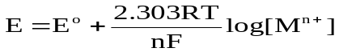

]
Log [ 0.1
nF
0.0591
-0.76
E
+
=
= - 0.76 – 0.03 V = - 0.79V
6. What is Pilling Bed worth ratio?
The ratio of the volume of oxide film formed to the volume of metal consumed is called Pilling Bed worth Ratio.
7.What is single electrode potential? (Nov.2010), (May 2011), (May 2005), (Nov. 2002), (Apr. 1996).
It is the tendency of a metallic electrode to lose or gain electrons when it is in contact with its own ions in solution
8.What is electrochemical series?
The arrangement of various metals in increasing order of their standard reduction potentials is called as electrochemical series or electromotive force series
9.Bolt and nut made of same metal is preferred in practice .why?
Bolt and nut made of same metal is preferred in practice because they do not permit local galvanic cell formation.
10.State the two conditions for wet corrosion to take place.
(i) When two dissimilar metals are in contact with each other in the presence of an aqueous solution or moisture, electrochemical or wet corrosion occurs.
(ii) When a metal is exposed to aan electrolyte with varying amount of oxygen. Then also wet corrosion take place.

11. What are the advantages of electroless plating over electroplating?
- No electricity is required and can be easily plated on insulators.(Plastics,Glass)
- Complicated parts can be easily plated.
- It produces hot surface and good wear resistance.
- Electroless coating possesses good mechanical, chemical and magnetic properties.

PART- B

- Derive the Nernst equation. Discuss in detail any two applications.
Nernst equation for electrode potential
Consider the following redox reaction
M^{n+} + ne− ↔ M
For such a redox reversible reaction, the free energy change (∆G) and its equilibrium constant (K) are inter related as
∆G = − RT ln K + RT ln [ Product ]
[ Reactant ]
= ∆G° + RT ln [ Product ] ........ (1)
[ Reactant ]
where,
∆G° = Standard free energy change
The above equation (1) is known as Van’t Hoff isotherm. The decrease in free energy (− ∆G) in the above reaction involves transfer of ‘n’ number of electrons, then ‘n’ faraday of electricity will flow. If E is the emf of the cell, then the total electrical energy (nEF) produced in the cell is
− ∆G = nEF
(or)
− ∆G° = nE°F ........ (2)
where,− ∆G = decrease in free energy change.
(or) − ∆G° = decrease in standard free energy change. Comparing equation 1 and 2, it becomes
− nEF = − nE°F + RT ln[ M ]
[ M^{n+}] . ....... (3)
Dividing the above equation (3) by – nF
[ the activity of solid metal [M] = 1 ]
E = E° − RTln 1
nF [ M^{n+} ]
In general, E = E° − RTln [Product] ....... (4)
nF [Reactant]
(or)
E = E° + RTln [ M^{n+} ]
nF
When, R = 8.314 J/K/mole; F = 96500 coulombs;
T = 298 K (25°C), the above equation becomes
(or)
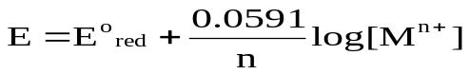....... (5)
In general,
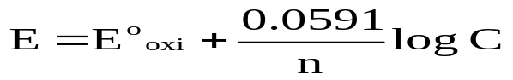
Similarly for oxidation potential
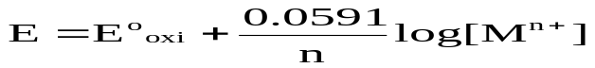....... (6)
The above equation 5 & 6 are known as “Nernst equation for single electrodepotential”.
Applications of Nernst equations
- Nernst equation is used to calculate electrode potential of unknown metal.
- Corrosion tendency of metals can be predicted.

- What are reference electrodes? Describe any two reference electrodes with neat diagram.
REFERENCE ELECTRODES (STANDARD ELECTRODES)
The electrode potential is found out by coupling the electrode with another reference electrode, the potential of which is known or arbitrarily fixed as zero. The important primary reference electrode used is a standard hydrogen electrode, standard electrode potential of which is taken as zero.
It is very difficult to set up a hydrogen electrode. So other electrodes called secondary reference electrodes like calomel electrodes are used.
Primary Reference Electrode (Standard Hydrogen electrode)Construction
Hydrogen electrode consists of platinum foil, that is connected to a platinum wire and sealed in a glass tube. Hydrogen gas is passed through the side arm of the glass tube. This electrode, when dipped in a 1N HCl and hydrogen gas at 1 atmospheric pressure is passed forms a standard hydrogen electrode. The electrode potential of SHE is zero at all temperatures.
It is represented as,
Pt , H₂(1 atm)/H⁺ (1 M); E° = 0 V
In a cell, when this electrode acts as anode, the electrode reaction can be written as
H₂ (g) → 2H⁺ + 2e−
When this electrode acts as cathode, the electrode reaction can be written as 2H⁺+2e⁻ → H₂(g)

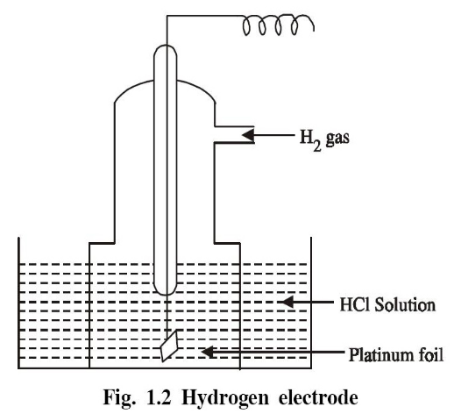
Limitations
- It requires hydrogen gas and is difficult to set up and transport.
- It requires considerable volume of test solution.
- The solution may poison the surface of the platinum electrode.
- The potential of the electrode is altered by changes in barometric pressure.

Secondary Reference Electrode [Saturated Calomel Electrode (SCE)]
Construction
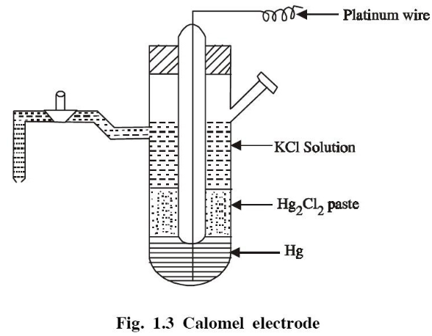
Calomel electrode consists of a glass tube containing mercury at the bottom over which mercurous chloride is placed. The remaining portion of the tube is filled with a saturated solution of KCl. The bottom of the tube is sealed with a platinum wire (Fig. 1.3). The side tube is used for making electrical contact with a salt bridge. The electrode potential of the calomel electrode is + 0.2422 V.

It is represented as,Hg , Hg₂Cl₂(s) , KCl(sat.solution); E° = 0.2422 V
If the electrode acts as anode the reaction is
2Hg_{(l)} → Hg₂²⁺+ 2e⁻
Hg₂²⁺ + 2Cl⁻→Hg₂Cl_{2(s)}
2Hg_{(l)} + 2Cl⁻ ↔ Hg₂Cl_{2(s)} + 2e⁻

If the electrode acts as cathode the reaction is
Hg₂Cl₂ (s) →Hg₂²⁺ + 2Cl⁻
Hg₂²⁺ + 2e⁻→ 2Hg_{(l)}
Hg₂Cl_{2(s)} + 2e⁻ ↔ 2Hg_{(l)} + 2Cl^{−`}
The electrode potential is given by (for example cathode)
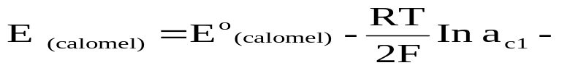
The electrode potential depends on the activity of the chloride ions and it decreases as the activity of the chloride ions increases. The single electrode potential of the three calomel electrodes on the hydrogen scale at 298 K are given as

0.1 N KCl = + 0.3338 V
1.0 N KCl = + 0.2800 V
Saturated KCl = + 0.2422 V.

- Explain single electrode potential determination by using SCE

Measurement of single electrode potential of Zn using saturated calomel electrode
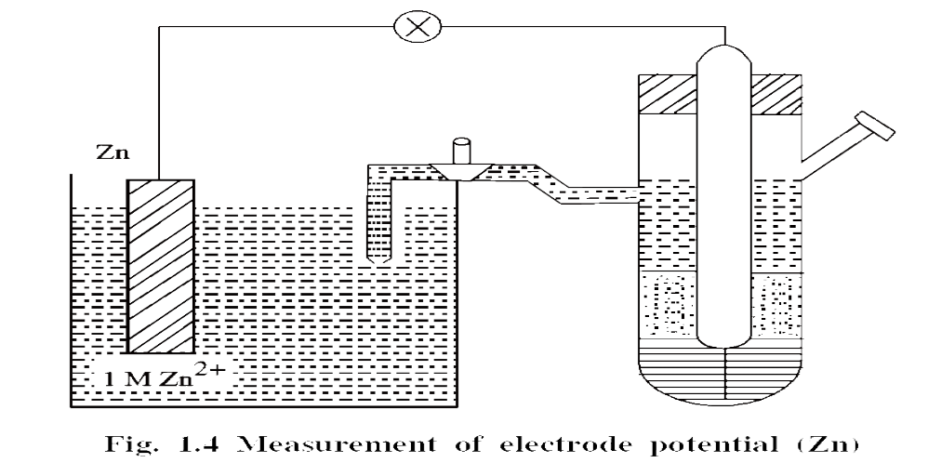
The saturated calomel electrode is coupled with another Zn electrode, the potential of which is to be determined (Fig. 1.4). Since the reduction potential of the coupled Zn electrode is less than E° of calomel electrode (+ 0.2422 V), the calomel electrode will act as cathode and the reaction is

Hg₂Cl_{2(s)} + 2e− ↔ 2Hg_{(l)} + 2Cl⁻
E_{cell} = E°_{right} − E°_{left}
E_{cell} = E°_{cal} − E°_{Zn}
E°_{Zn} = E°_{cal} − E_{cell}
= + 0.2422 − 1.0025
E°_{Zn} = − 0.7603 volt .

- Explain the applications of electrochemical series.
Significance of emf series (or) Applications of electrochemical series (or) Applications of Nernst equation

1. Calculation of standard emf of the cell
The standard emf of a cell (E°) can be calculated if the standard electrode potential values are known using the following relation.E°_{cell} = E°_{R.H.E} − E°_{L.H.E}
2. Relative ease of oxidation (or) reduction
Higher the value of standard reduction potential (+ve value) greater is the tendency to get reduced. (i.e. Metals on the top (–ve value) are more easily ionised) (oxidised).
(a) The fluorine has higher positive value of standard reduction potential (+ 2.87 V), and shows higher tendency towards reduction.
(b) The lithium has highest negative value (− 3.01 V) and shows higher tendency towards oxidation.
3. Displacement of one element by the other
Metals which lie higher in the emf series can displace those elements which lie below them in the series. For example, we may know whether Cu will displace Zn from the solution or vice-versa. We know that standard reduction potential of Cu & Zn.
i.e., E°Cu²⁺/Cu = + 0.34 V and E°Zn²⁺/Zn = − 0.76 V.
So, Cu²⁺ has a great tendency to acquire Cu form, than Zn²⁺ has for acquiring Zn form.
So, Cu²⁺ has a great tendency to acquire Cu form, than Zn²⁺ has for acquiring Zn form.
4. Determination of equilibrium constant for the reaction
Standard electrode potential can also be used to determine the equilibrium constant (K) for the reaction. We know that

From the value of E°, the equilibrium constant for the cell reaction can be calculated.
5. Hydrogen Displacement Behaviour
Metals with negative reduction potential (i.e., the metals placed above H₂ in the emf series) will displace the hydrogen from an acid solution.
Example:
Zinc reacts with dil H₂SO₄ to give H₂ but Ag does not, why?
Zn + H₂SO₄ −−−>ZnSO₄ + H₂ ↑E°_{Zn} = − 0.76 volt
The metal with positive reduction potential (ie., the metals placed below H₂ in the emf series) will not displace the hydrogen from an acid solution.
Ag + H₂SO₄ → No reactionEº _{Ag} = + 0.80 volt
6. Predicting Spontaneity of Redox Reactions
Spontaneity of redox reaction can be predicted from the emf (E°) value of the complete cell reaction.
(i) If the E° of the cell is positive, the reaction is spontaneous.
(ii) If the E° of the cell is negative, the reaction is not feasible.
In general, an element having lower reduction potential can displace another metal having higher reduction potential from its salt solution spontaneously.

- Explain the types of electrochemical corrosion with examples.
Galvanic Corrosion

When two different metals are in contact with each other in presence of an aqueous solution or moisture, galvanic corrosion occurs.
Here, the more active metal (with more negative electrode potential) acts as anode and the less active metal (with less negative electrode potential) acts as cathode.

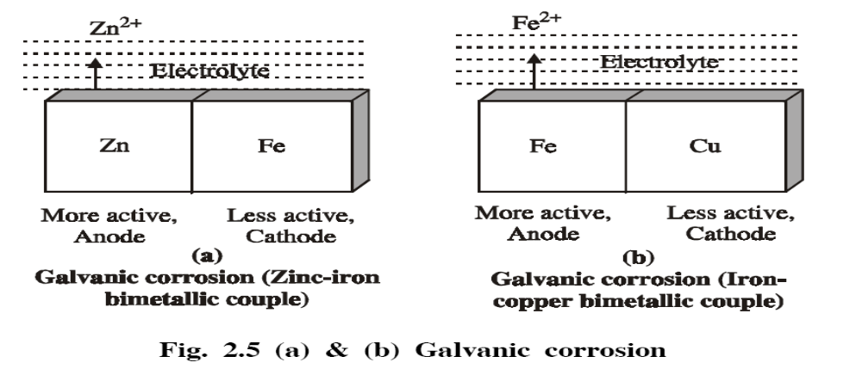
Example: Zn – Fe Couple
Fig. 2.5 (a) represents Zn-Fe couple, in which zinc (more active or higher in emf series) dissolves in preference to iron (less active metal) i.e., Zn acts as anode and undergoes corrosion and Fe acts as cathode.

Example: Cu – Fe Couple
Fig. 2.5 (b) represents Fe − Cu couple, in which iron (more active, when compared to Cu) dissolves in preference to copper (less active) i.e., Fe acts as anode and undergoes corrosion and Cu acts as cathode.

Examples for Galvanic Corrosion
(i) Steel screw in a brass marine hardware corrodes
This is due to galvanic corrosion. Iron (higer position in electrochemical series) becomes anodic and is attacked andcorroded, while brass (lower in electrochemical series) acts as cathodic and is not attacked.

(ii) Bold and Nut made of the same metal is preferred
It is preferred in practice, because galvanic corrosion is avoided due to homogeneous metals (no anodic and cathodicpart)

Prevention
Galvanic corrosion can be minimised by providing an insulating material between the two metals

Differential aeration (or) concentration cell corrosion`
This type of corrosion occurs when a metal is exposed to varying concentration of oxygen or any electrolyte on the surface of the base metal.

Example:
Metals partially immersed in water (or) conducting solution (called water line corrosion).

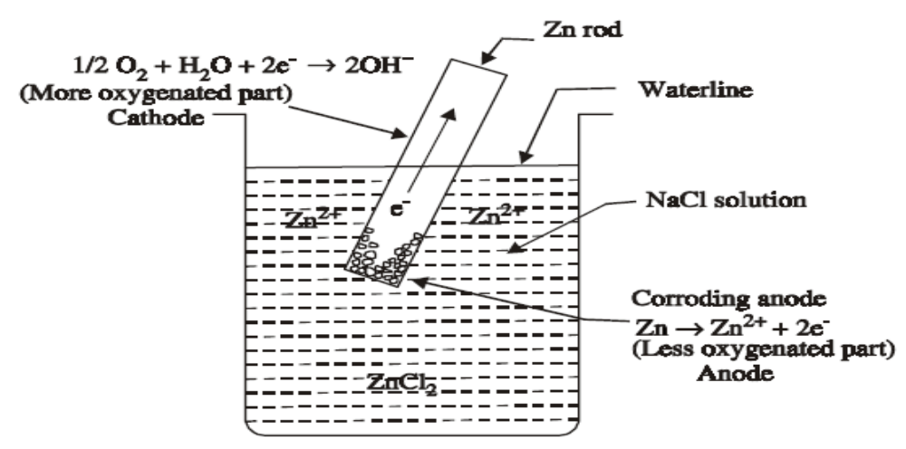Differential Aeration Corrosion
If a metal is partially immersed in a conducting solution the metal part above the solution is more aerated and hence become cathodic. On the other hand, the metal part inside the solution is less aerated and thus, become anodic and suffers corrosion.
At anode (less aerated) corrosion occurs M −−−−−> M²⁺ + 2e⁻
At cathode (more aerated part) OH⁻ ions are produced
½ O₂ + H₂O + 2e⁻ −−−−−> 2OH⁻

- Pitting or localised corrosion.
- Crevice corrosion.
- Pipeline corrosion.
- Corrosion on wire fence.
Examples for Differential Aeration Corrosion
a) Pitting or Localized Corrosion.
Pitting is a localised attack, resulting in the formation of a hole around which the metal is relatively unattached.

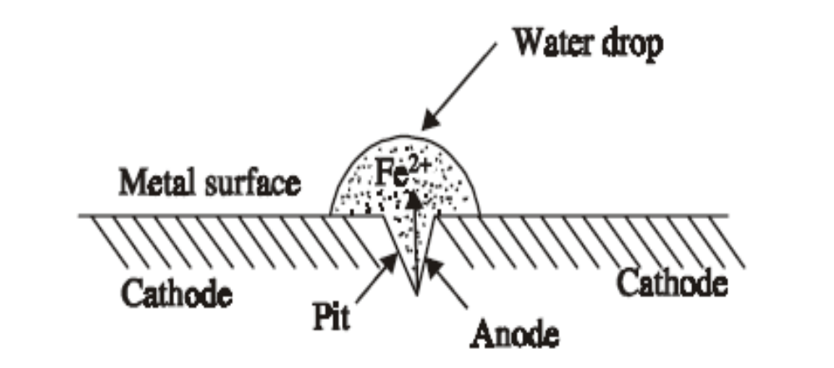
Fig. 2.7 Pitting Corrosion

Example:
Metal area covered by a drop of water, sand, dust, scale, etc.

Let us consider a drop of water or aqueous NaCl resting on a metal surface (Fig. 2.7). The area covered by the drop of water acts as an anode due to less oxygen concentration and suffers corrosion. The uncovered area (freely exposed to air) acts as a cathode due to high oxygen concentration.

The rate of corrosion will be more, when the area of cathode is larger and the area of anode is smaller. Therefore, more and more material is removed from the same spot. Thus a small hole or pit is formed on the surface of the metal.

At Anode
Iron is oxidised to Fe²⁺ ions
Fe −−−−−> Fe²⁺ + 2e-

At Cathode
Oxygen is converted to OH⁻ ions.
½ O₂ + H₂O + 2e⁻ −−−−−> 2OH⁻
Net reaction is
This type of intense corrosion is called pitting.

(b) Crevice Corrosion
If a crevice between different metallic objects or between metal and non-metallic material is in contact with liquids, the crevice becomes the anodic region and suffers corrosion.
This is due to less oxygen in crevice area. The exposed areas act as the cathode (Fig. 2.8).

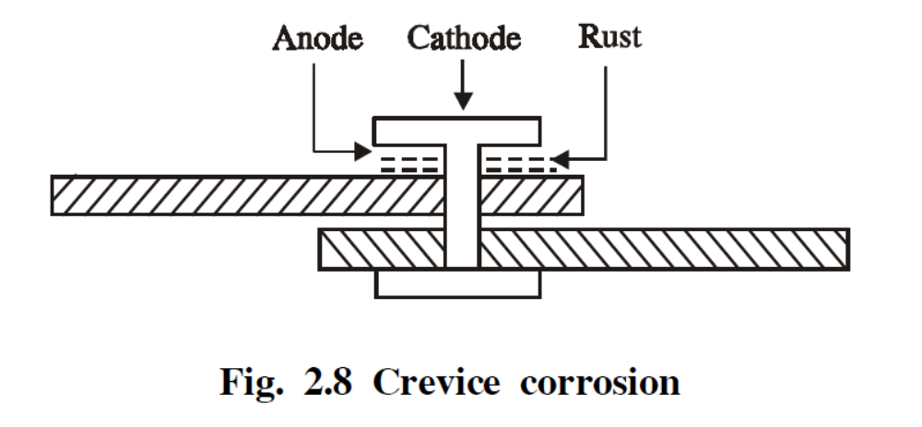
(c) Pipeline Corrosion

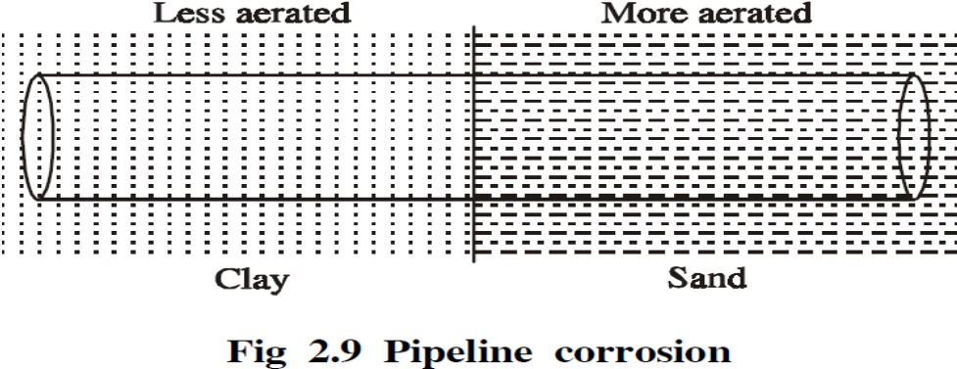
- Differential aeration corrosion may also occur in different parts of pipeline.
- Buried pipelines or cables passing from one type of soil to another say, from clay (less aerated) to sand (more aerated) may get corroded due to differential aeration.
(d) Corrosion on Wire - Fence
Fig. 2.10 shows a wire fence in which the areas where the wires cross are less aerated than the rest of the fence and hence corrosion occurs at the wire crossings, which are anodic.

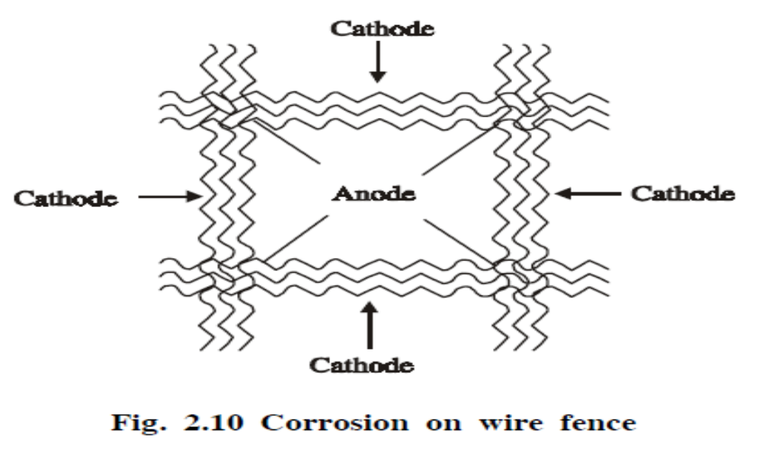
Other Examples for Differential Aeration Corrosion
(i) Corrosion occurring under metal washers, where oxygen cannot diffuse easily.
(ii) Lead pipeline passing through clay to cinders undergo corrosion. Since the pipeline under cinders is more aerated, it gets corroded easily.

- Describe the mechanism of chemical corrosion.How does it differ from electrochemical corrosion?
DRY CHEMICAL CORROSION
Oxidation Corrosion (or) Corrosion by Oxygen
- Oxidation corrosion is brought about by the direct attack of oxygen at low or high temperatures on metal surface in the absence of moisture. Alkali metals (Li, Na, K, etc.)
- Alkaline-earth metals (Mg, Ca, Sn, etc.) are rapidly oxidised at low temperature. At high temperature, almost all metals (except, Ag, Au and Pt) are oxidised.
Mechanism of Dry Corrosion
(i) Oxidation occurs first at the surface of the metal resulting in the formation of metal ions
(M²⁺), which occurs at the metal / oxide interface.
M −−−−−> M²⁺ + 2e⁻
(ii) Oxygen changes to ionic form (O²⁻) due to the transfer of electron from metal, which occurs at the oxides film / environment interface
½ O₂ + 2e⁻ −−−−−> O²⁻
(iii) Oxide ions reacts with the metal ion to form the metal-oxide film.
M + ½ O₂ −−−−−> M²⁺ + O²⁻ ≡ MO
(Metal-oxide film)
Once the metal surface is converted to a monolayer of metal-oxide, for further corrosion (oxidation) to occur, the metal ion diffuses outward through the metal-oxide barrier.
Thus the growth of oxide film commences perpendicular to the metal surface (Fig. 2.2).

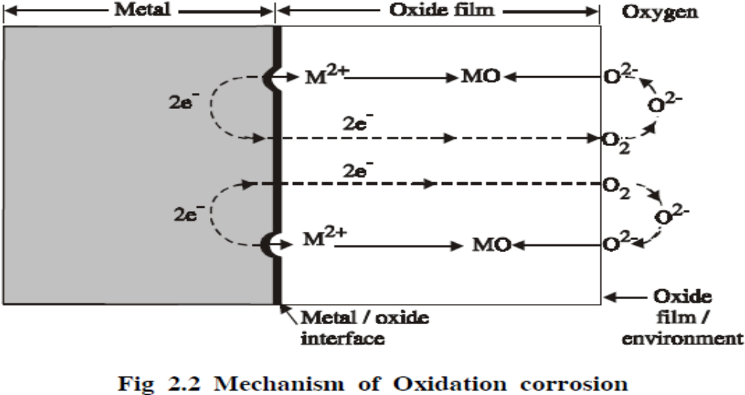

Nature Of Oxide Film
The nature of oxide film formed on the metal surface plays an important role in oxidation corrosion.
(i) Stable Oxide Layer
A stable oxide layer is a fine-grained in structure, and gets adsorbed tightly to the metal surface. Such a layer is impervious in nature and stops further oxygen attack through diffusion. Such a film behaves as a protective coating and no further corrosion can develop.

Example:
Oxides of Al, Sn, Pb, Cu, etc., are stable oxide layers.

(ii) Unstable Oxide Layer
Unstable oxide layer is mainly produced on the surface of noble metals, which decomposes back into the metal and oxygen.
Example:Oxides of Pt, Ag, etc., are unstable oxide layers.

(iii) Volatile Oxide Layer:
The oxide layer volatilizes as soon as it is formed, leaving the metal surface for further corrosion.
Example:Molybdenum oxide (MoO₃) is volatile.

(iv) Protective (or) Non-Protective oxide film (Pilling- Bedworth rule)
(a) According to Pilling-Bedworth rule, if the volume of the oxide layer formed is less than the volume of the metal, the oxide layer is porous and non-protective.
Example:
The volume of oxides of alkali and alkaline earth metals such as Na, Mg, Ca, etc., is less than the volume of the metal consumed. Hence the oxide layer formed is porous and non-protective.
(b) On the other hand, if the volume of the oxide layer formed is greater than the volume of the metal, the oxide layer is non-porous and protective.

Example
The volume of oxides of heavy metals such as Pb, Sn, etc., is greater than the volume of the metal. Hence the oxide layer formed is non-porous and protective.

Difference between Chemical and Electro Chemical Corrosion
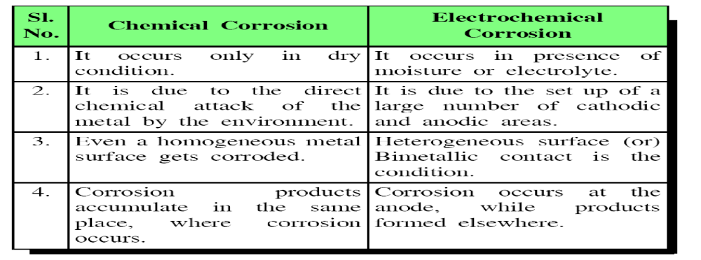
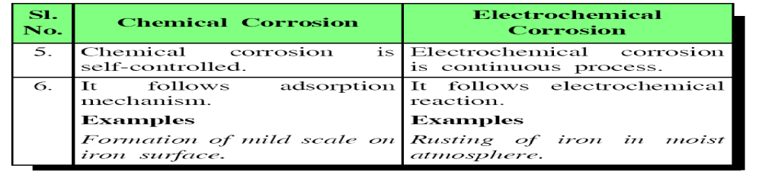

- Write a short note on Hydrogen embrittlement and Decarburization.

(a) Hydrogen embrittlement (at ordinary temperature)

When metals contact to H2S at ordinary temperature causes evolution of atomic hydrogen.
Fe + H₂S −−−−−>FeS + 2H
This atomic hydrogen diffuses readily into the metal and collects in the voids, where it recombines to form molecular hydrogen.
H + H −−−−−> H₂↑
Collection of these hydrogen gases in the voids develop very high pressure, which causes cracks and blisters on metal.
Thus, the process of formation of cracks and blisters on the metal surface, due to high pressure of hydrogen gas is called hydrogen embrittlement.

(b) Decarburisation (at Higher Temperature)
At higher temperature atomic hydrogen is formed by the thermal dissociation of molecular hydrogen.
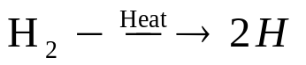
when steel is exposed to this environment, the atomic hydrogen readily combines with carbon of steel and produces methane gas.
C + 4H −−−−−> CH₄↑
Collection of these gases in the voids develop very high pressure, which causes cracking.
Thus the process of decrease in carbon content in steel is termed as “decarburisation” of steel

- Describe the mechanism of electrochemical corrosion by (i) Hydrogen evolution (ii) Oxygen absorbtion.
WET ELECTROOCHEMICAL CORROSION
Wet corrosion occurs under the following conditions.
(i) When two dissimilar metals or alloys are in contact with each other in the presence of an aqueous solution or moisture.
(ii) When a metal is exposed to varying concentration of oxygen or any electrolyte.
(a) Hydrogen Evolution Type Corrosion
“All metals above hydrogen in the electrochemical series have a tendency to get dissolved in acidic solution with simultaneous evolution of hydrogen gas”
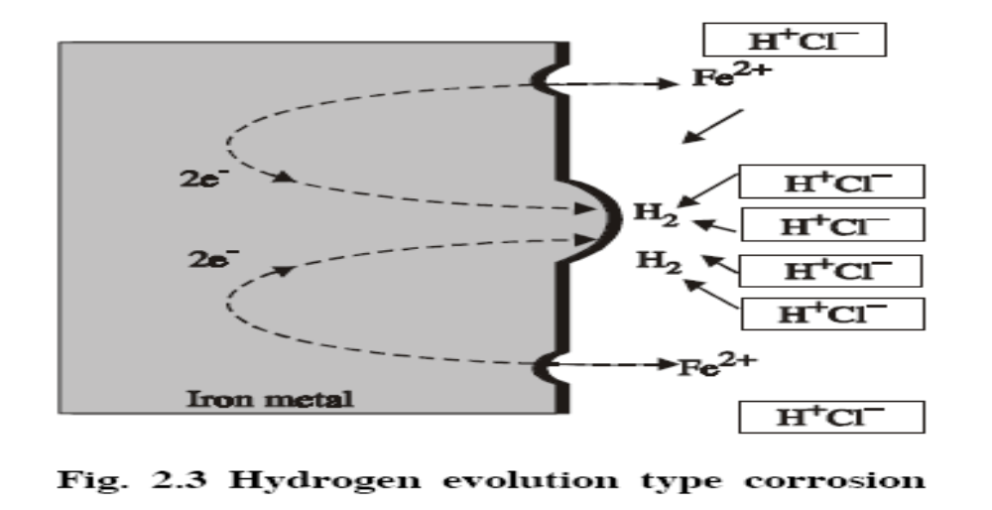
When iron metal contacts with non-oxidising acid like HCl, H₂ evolution occurs.
At Anode
Iron undergoes dissolution to give Fe²⁺ ions with the liberation of electrons.
Fe −−−−−> Fe+ + 2e- (Oxidation)
At Cathode
The liberated electrons flow from anodic to cathodic part, where H⁺ ions get reduced to H₂.
2H⁺ + 2e- −−−−−> H₂↑ (Reduction)
The surface of iron is usually, coated with a thin film of iron oxide. However, if the oxide film develops, some crack will come and anodic areas are created on the surface while the remaining part acts as cathode
When iron metal contacts with a neutral solution of an electrolyte in presence of oxygen, OH⁻ions are formed.
(b) Absorption of oxygen (or) Formation of hydroxide ion type corrosion
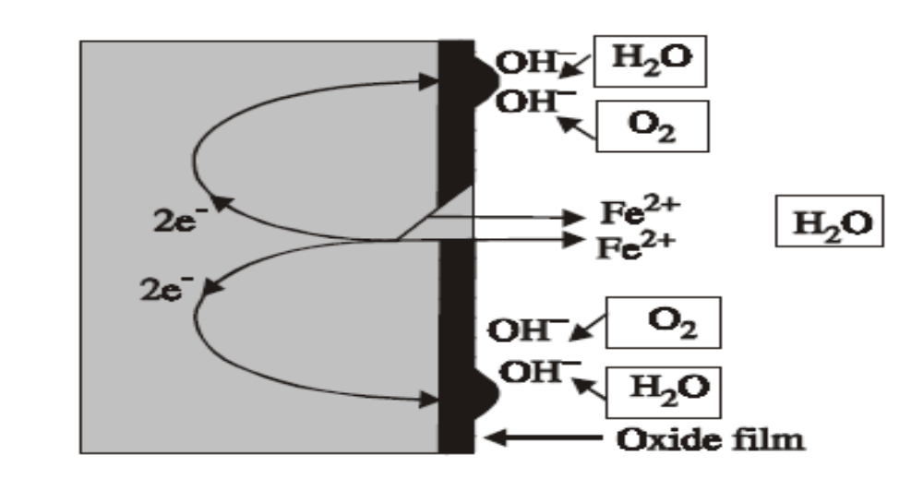
Iron dissolves as Fe²⁺ with the liberation of electrons.

At Anode
Fe −−−−−> Fe²⁺ + 2e- (oxidation)`

At Cathode
The liberated electrons flow from anodic to cathodic part through metal, where the electrons are taken up by the dissolved oxygen to form OH⁻ ions.
½ O₂ + H₂O + 2e- −−−−−> 2OH⁻
Thus, the net corrosion reaction is
Fe²⁺ + 2OH-−−−−−>Fe(OH)₂↓
If enough O₂ is present Fe(OH)₂ is easily oxidised to Fe(OH)₃, a rust (Fe₂O₃H₂O)

4Fe(OH)₂ + O₂ + 2H₂O −−−−−> 4Fe(OH)₃

9.Describe the sacrificial anode and impressed current cathodic protection methods of corrosion control.
By Cathodic Protection
The principle involved in the cathodic protection is to force the metal to behave like a cathode.
The important cathodic protections are
(i) Sacrificial anodic protection.
(ii) Impressed current cathodic protection

(i) Sacrificial Anadic Protection Method
In this method, the metallic structure to be protected is made cathode by connecting it with more active metal (anodic metal). So that all the corrosion will concentrate only on the active metal. The artificially made anode thus gradually gets corroded protecting the original metallic structure. Hence this process is otherwise known as sacrificial anodic protection.

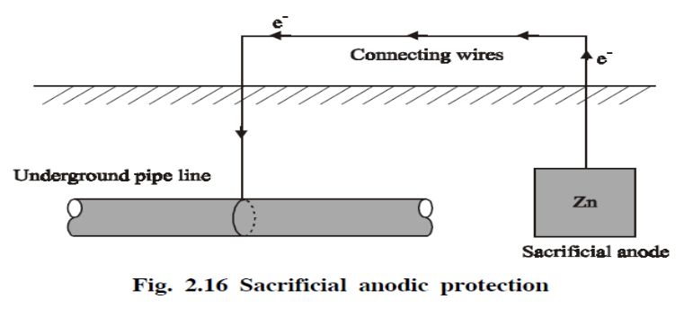
Aluminium, Zinc, Magnesium are used as sacrificial anodes.

Applications of Sacrificial Anodic Protection
This method is used for the protection of ships and boats. Sheets of Mg or Zn are hung around the hull of the ship (Fig. 2.17).
Zn or Mg will act as anode compared to iron (ship or boat is made of iron), so corrosion concentrates on Zn or Mg. Since they are sacrificed in the process of saving iron, they are called sacrificial anodes.
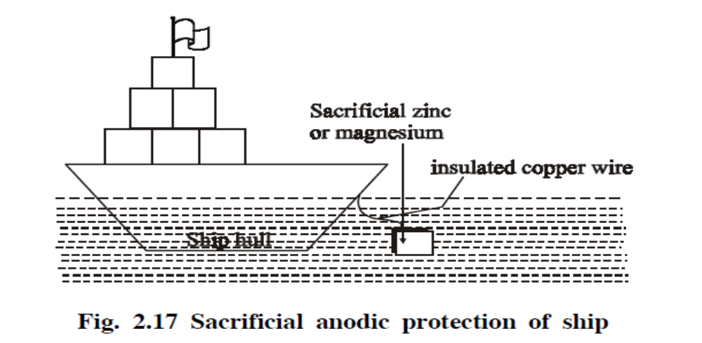

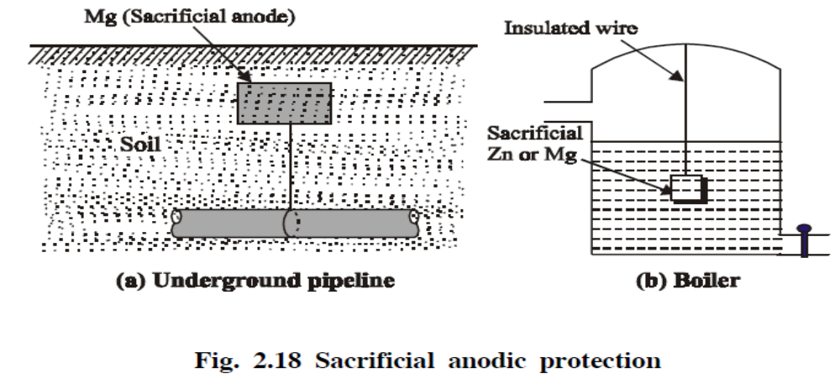
(d) Protection of underground pipelines, cables from soil corrosion (Fig. 2.18(a)).
(c) Insertion of Mg sheets into the domestic water boilers to prevent the formation of rust (Fig. 2.18(b)).
(d) Calcium metal is employed to minimize engine corrosion.

(iii) Impressed Current Cathodic Protection Method
In this method, an impressed current is applied in the opposite direction of the corrosion current to nullify it, and the corroding metal is converted from anode to cathode.

This can be done by connecting negative terminal of the battery to the metallic structure, to be protected, and positive terminal of the battery is connected to an inert anode.

Inert anodes used for this purpose are graphite, platinised titanium. The anode is buried in a “back fill” (containing mixture of gypsum, coke, breeze, sodium sulphate). The “back fill” provides good electrical contact to anode Fig. 2.19).

Applications of Impressed Current Protection
Structures like tanks, pipelines, transmission line towers, underground water pipe lines, oil pipe lines, ships, etc., can be protected by this method.

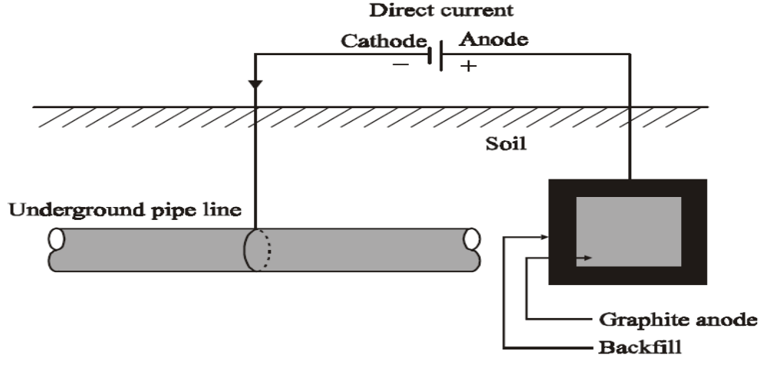
Fig. 2.19 Impressed Current Cathodic Protection

10.What are important factors with influence the rate of corrosion of a metal?
Factors Influencing the Rate of Corrosion
The rate and extent of corrosion mainly depends on
(i) Nature of the metal.
(ii) Nature of the environment.

Nature of the Metal

(a) Position in EMF Series
The extent of corrosion depends on the position of the metal in the emf series. Metals above the hydrogen in emf series get corroded vigorously.
Lower the reduction potential, greater is the rate of corrosion. When two metals are in electrical contact, the more active metal (or the metal having high negative reduction potential) undergoes corrosion.

∴ The rate and severity of corrosion depends on the difference in their positions in the emf series. Greater the difference faster is the corrosion rate.

(b) Relative Areas of the Anode and Cathode
The rate of corrosion will be more, when the cathodic area is larger. When the cathodic area is larger, the demand for electrons will be more and this results in an increased rate of corrosion (dissolution) of metals at anodic area.

(c) Purity of the Metal
The 100% pure metal will not undergo any type of corrosion. But, the presence of impurities in a metal create heterogeneity and thus galvanic cells are set up with distinct anodic and cathodic area in the metal.

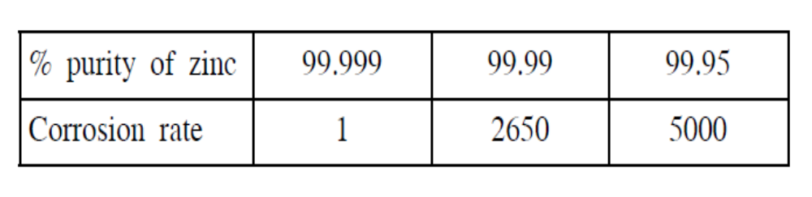 Higher the percentage of impurity, faster is the rate of corrosion of the anodic metal. The effect of impurities on the rate of corrosion of zinc is given below.

(d) Over Voltage or Over Potential
The over voltage of a metal in the corrosive environment is inversely proportional to corrosion rate.
(e) Nature of the surface film
The nature of the oxide film formed on the metal surface decides the extent of corrosion which can be decided by Pilling-Bedworth rule
In the case of alkali and alkaline earth metals such as Mg, Ca, etc. form oxide, whose volume is less than the volume of the metal. Hence the oxide film will be porous and non-protective and bring about further corrosion.
But in heavy metals like Al, Cr, etc. form oxide,
whose volume is greater than that of the metal. Hence the oxide film will be non-porous and protective and prevents further corrosion.

(f) Nature of the Corrosion Product
If the corrosion product is soluble in the corroding medium, the corrosion rate will be faster. Similarly, if the corrosion product is volatile (like MoO3 on Mo surface), the corrosion rate will be faster.

Nature of the Environment
(a) Temperature
The rate of corrosion is directly proportional to temperature. This is because, the rate of chemical reaction and the rate of diffusion of the ions increases with rise in temperature. Hence the rate of corrosion increases with temperature.

(b) Humidity
The rate of corrosion will be more, when the humidity in the environment is high. The moisture acts as a solvent for the oxygen in the air to produce the electrolyte, which is essential for setting up a corrosion cell.

(c) Presence of Corrosive Gases
The acidic gases like, CO₂, SO₂, H₂S and fumes of HCl, H₂SO₄, etc., produce electrolytes, which are acidic and increases the electrochemical corrosion.

(d) Presence of Suspended Particles
Particles like, NaCl, (NH4)2SO4 along with moisture act as powerful electrolytes and thus accelerate the electrochemical corrosion.

(e) Effect of pH
The possibility of corrosion with respect to pH of the electrolytic solution and the electrode potential of the metal is correlated with the help of a pourbaix diagram.

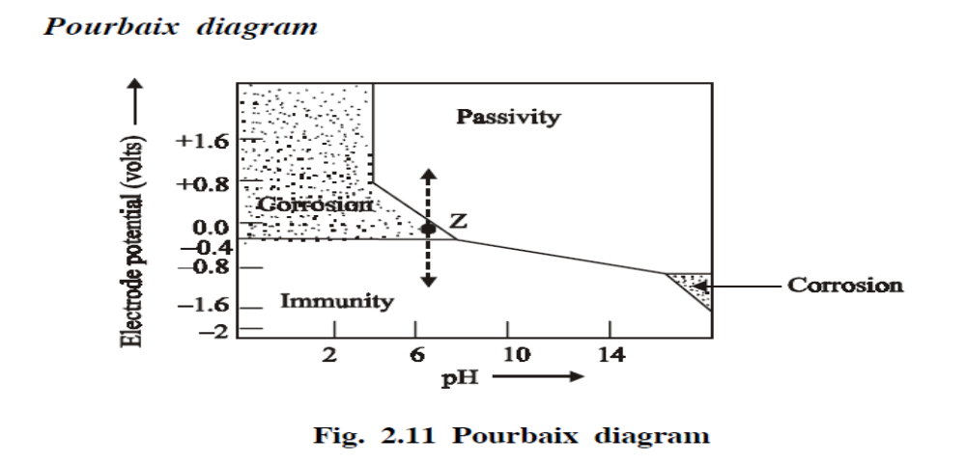
The pourbaix diagram for iron in water is shown in fig. 2.11. It shows clearly the zones of corrosion, immunity and passivity. In the diagram, ‘Z’ is the point where pH = 7 and the electrode potential = − 0.4 V. It is present in the corrosion zone. This clearly shows that iron rusts in water under those conditions. In actual practice, it is observed to be true.

From the diagram (Fig. 2.11) it is clear that the rate of corrosion can be altered by shifting the point ‘Z’ into immunity or passivity regions. The iron will be immune to corrosion, if the potential is changed to about − 0.8 V by applying external current. On the other hand, the rate of corrosion of iron can also be reduced by moving into the passivity region by applying positive potential.

The diagram clearly indicates that the rate of corrosion can also be reduced by increasing the pH of the solution by adding alkali.
Thus the rate of corrosion will be maximum when the corrosive environment is acidic. i.e. pH is less than 7.

11.How do you control corrosion by proper designing and selection of materials?
Corrosion Control
The rate of corrosion can be controlled by either modifying the metal or the environment.

Control of corrosion by Modifying the Metal
1.By selection of the metal
2. By using pure metal
3. By using pure metal
4. By using pure metal

1. By Selection of the Metal
Selection of right type of metal is the main factor for corrosion control. Thus, noble metals are used in ornaments and in surgical instruments, as they are most immune to corrosion.

2. By using Pure Metal
Pure metals have higher corrosion resistance. Even a small amount of impurity may lead to severe corrosion.

3. By Alloying
Corrosion resistance of many metals can be improved by alloying. For example, stainless steel containing chromium produce a coherent oxide film, which protects the steel from further attack.

4. By Proper Design
Some of the important rules for designing, which must be observed are given below.
(i) Avoid galvanic corrosion
(ii) Drainage affects corrosion
(iii) Avoid sharp corners and bends
(iv) Avoid crevices

(i) Avoid Galvanic Corrosion
If two different metals are joined, galvanic corrosion will occur. In such a case galvanic corrosion is prevented by
(a) Selecting the metals as close as possible in the electrochemical series.
(b) Providing smaller area for cathode and larger area for anode.
(c) Inserting an insulating material between the two metals (Fig. 2.12).
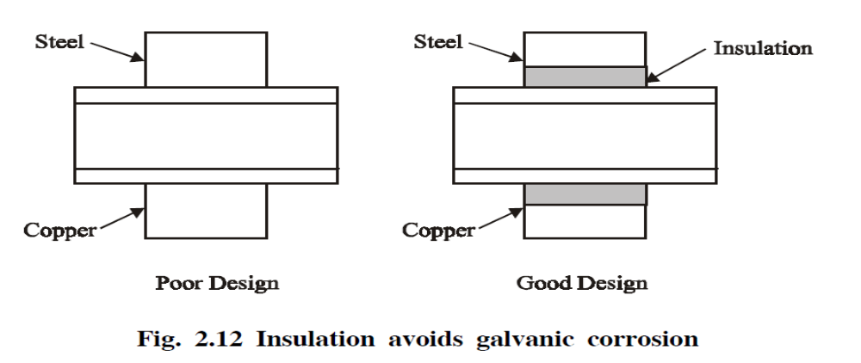
Tanks and other containers must be designed in such a way that, the whole of the liquid should be drained off completely (Fig. 2.13).
(ii) Drainage Affects Corrosion
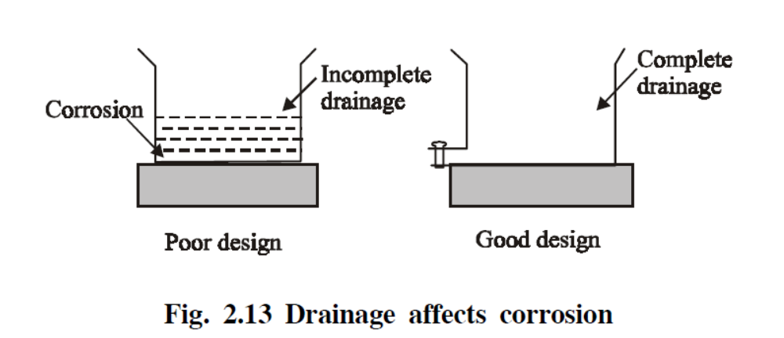

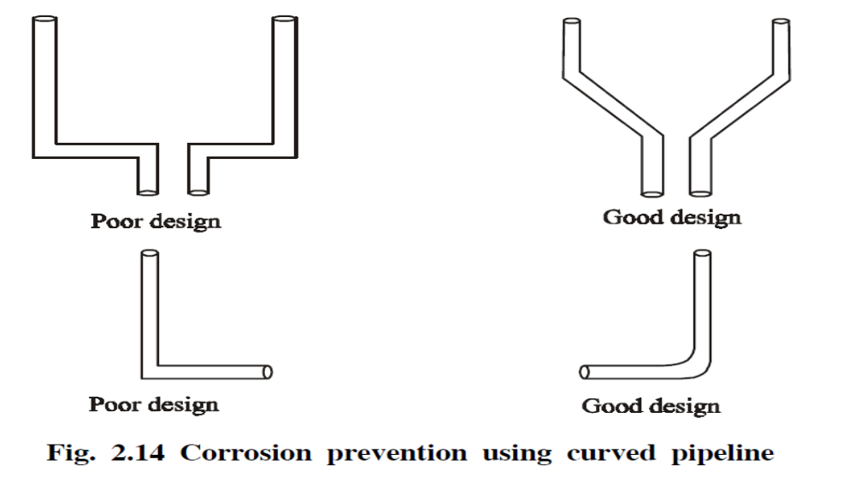

(iv) Avoid Crevices
Crevices allow moisture and dirt, which results in increased electrochemical corrosion. This can be prevented by filling the crevices with a filler (Fig. 2.15).
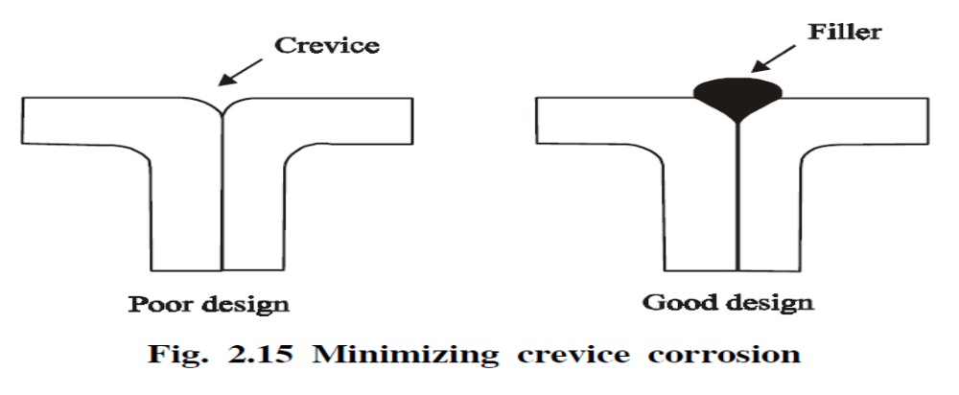 Riveted joints produce crevice corrosion, so welded joints are preferred.

12.What is paint? Discuss the ingredients of paint and explain their functions.
PAINTS
Paint is a mechanical dispersion of one or more finely divided pigments in a medium (thinner + vehicle).
When a paint is applied to a metal surface, the thinner evaporates, while the vehicle undergoes slow oxidation forming a pigmented film

`
Constituents and their functions of a paint
- Pigments
- Vehicle (or) drying oil
- Thinners (or) solvents
- Extenders (or) fillers
- Driers
- Plasticisers
- Anti-skinning agents

1. Pigments

Pigments are solid and colour producing substances in the paint.
Functions
(i) It gives colour and opacity to the film.
(ii) It also provides strength to the film.
(iii) It protects the film by reflecting the destructive
uv rays.
(iv) It increases weather resistance of the film.
Example:
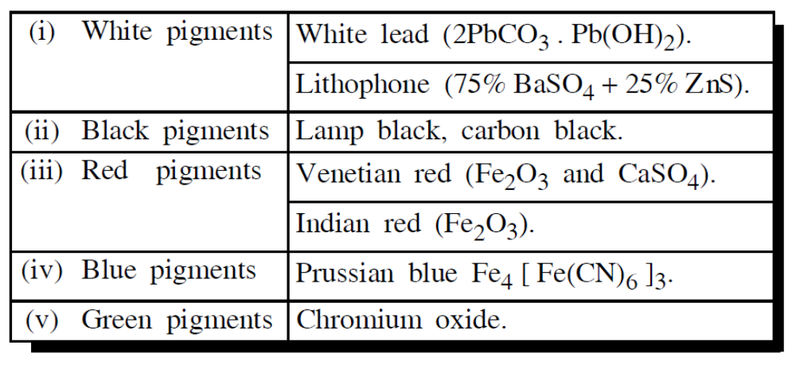
- Vehicle (or) Drying Oil

This is a non-volatile portion of a medium and film forming constituent of the paint. These are high molecularweight fatty acids present in vegetable and animal oils.
Functions
(i) They form a protective film by the oxidation and polymerisation of the oil.
(ii) They hold the pigment particles together on the metalsurface.
(iii) They impart water repellency, toughness and durability to the film.

3. Thinners (or) Solvents
This is a volatile portion of a medium. It easily evaporates after application of the paint.

Functions
(i) It reduces the viscosity of the paint, so that it can be easily applied on the surface.
(ii) It dissolves the oil, pigments, etc. and produces a homogeneous mixture.
(iii) It increases the elasticity of the film.
(iv) It increases the penetrating power of the vehicle.
Example: Linseed oil, Dehydrated Castor Oil

4. Extenders (or) fillers

These are white (or) colourless pigments.
Functions
(i) It reduces the cost of the paint.
(ii) It retards the settling of the pigment in all paints.
(iii) It modifies the shades of the pigments.
(iv) It prevents shrinkage and cracking.

Functions
(i) They act as oxygen-carriers (or) catalysts.
(ii) They provide oxygen, which is essential for oxidation, polymerisation of drying oil.

5. Driers
These are the substances, used to accelerate the process of drying.
These are chemicals added to the paint to provide elasticity to the film and to prevent cracking of the film.

6. Plasticisers

Example: Triphenyl phosphate, tricresyl phosphate, etc.

7. Anti – Skinning Agents

These are chemicals added to the paint to prevent gelling and skinning of the paint.
Example: Polyhydroxy phenol.

13.What is electroless plating? Explain pretreatment of object, bath composition, mechanism and applications of electroless nickel plating.
Electro less Plating
Electro less plating is a technique of depositing a noble metal (from its salt solution) on a catalytically active surface of the metal, to be protected, by using a suitable reducing agent without using electrical energy.
Principle

The reducing agent reduces the metallic ions to metal, which gets plated over the catalytically activated surface giving a uniform thin coating.

Metal ions + Reducing agent −−−−−>Metal +Oxidised product(s)
( Deposited)

Example:
Electroless Nickel Plating

Pretreatment and activation of the surface
Step : 1
The surface to be plated is first degreased by using organic solvents or alkali, followed by acid treatment. Activation depend on the type of metal (or) alloy (or) non-metal used

Example (i) The surface of the stainless steel is activated by dipping in hot solution of 50% dil H₂SO₄.
(ii) The surface of Mg alloy is activated by thin coating of Zn and Cu over it.

(iii) Metals and alloys like Al, Cu, Fe, brass, etc., can be directly Ni − plated without activation.
(iv) Non-metallic articles (like plastics, glass, etc.,) are activated by dipping them in the solution containing SnCl₂+ HCl, followed by dipping in palladium chloride solution. On drying a thin layer of Pd is formed on the surface.
Step II
Preparation of Plating bath
The plating bath consists of the following ingredients
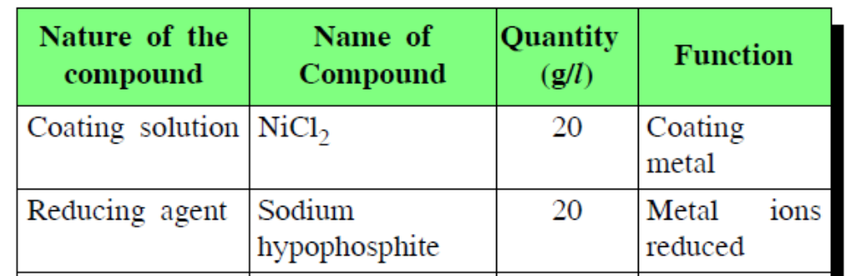
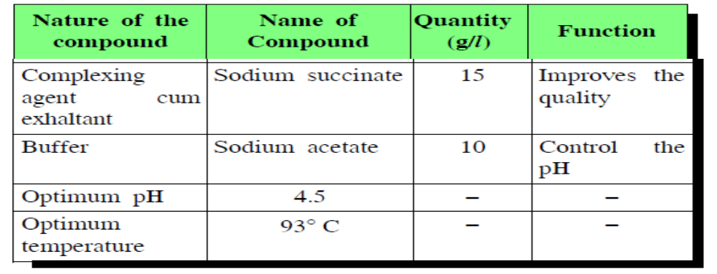
Procedure for Plating
Step III
The pretreated object is immersed in the plating bath for the required time. During which the following reduction reaction will occur and the Ni gets coated over the object.

Various Reactions
Ni²⁺ + 2e- −−−−−> Ni
At Cathode:
H₂PO₂⁻ + H₂O −−−−−> H₂PO₃⁻ + 2H⁺ + 2e⁻
At Anode:
Net reaction:
Ni²⁺ + H₂PO₂⁻+H₂O −−−−−> Ni + H₂PO₃⁻+ 2H⁺

Applications
1. Electroless Ni–plating is extensively used in electronic appliances.
2. Electroless Ni–plating is used in domestic as well as automotive fields (eg.,jewellery, tops of perfume bottles.)
3. Electroless Ni–coated polymers are used in decorative and functional works.
4. Electroless Cu & Ni coated plastic cabinets are used in digital as well as electronic instruments.

Advantages of Electroless Plating Over Electroplating
1. No electricity is required.
2. Electroless plating on insulators (like plastics, glass) and semiconductors can be easily carried out.
3.Complicated parts can also be plated uniformly.
4. Electroless coatings possess good mechanical, chemical and magnetic properties.

14.What is electroplating? Discuss the plating composition, mechanism of copper plating.

Definition
Electroplating is a process in which the coating metal is deposited on the base metal by passing a direct current through an electrolytic solution containing the soluble salt of the coating metal.

Objectives

To give corrosion protection to the base metal
To increase commercial value of inferior metals
To increase the electrical and thermal conductivity
To increase strength and wear resistance

Components for electroplating
Electrolyte is an aqueous solution of CuSO₄
The electronically conducting cathode (Object to be plated)
Impure copper (anode)
A direct current source

Process
The metal object to be plated is first with dilHCl or Dil. H₂SO₄. The cleaned object is then made cathode of an electrolytic cell and copper plate as the anode CuSO₄ and Dil H₂SO₄ solutions are taken as the electrolyte. When the current is passed from the battery through the solution, copper dissolves in the electrolyte and deposits uniformly on the metal object.

Various chemical reactions
CuSO₄ionises as

CuSO₄→ Cu²⁺ + SO₄²⁻

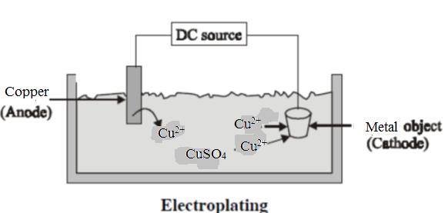

At Cathode : On passing current Cu²⁺ ions move to the cathode and get deposited there as Cu metal.

Cu²⁺ + 2e- → Cu

At Anode: The free sulphate ions migrate to the copper anode and dissolves an equivalent amount of Cu to form CuSO₄

Cu + SO₄²⁻→ CuSO₄

In order to get strong, adherent and smooth deposit certain additives (glue, gelatin.) are added to the electrolytic bath. The improve the brightness of deposit , brightening agents are added in the electrolytic bath. The favourable conditioning for a copper electrdepositsareoptimum temperature (40-45ºC) optimum current density (30-40mA/ cm²) and low metal ion concentrations.

